Woodfibre LNG construction is finally a go

Construction to begin in earnest in 2023 on $1.6 billion plant in Squamish
By Nelson Bennett | April 14, 2022, 2:10pm
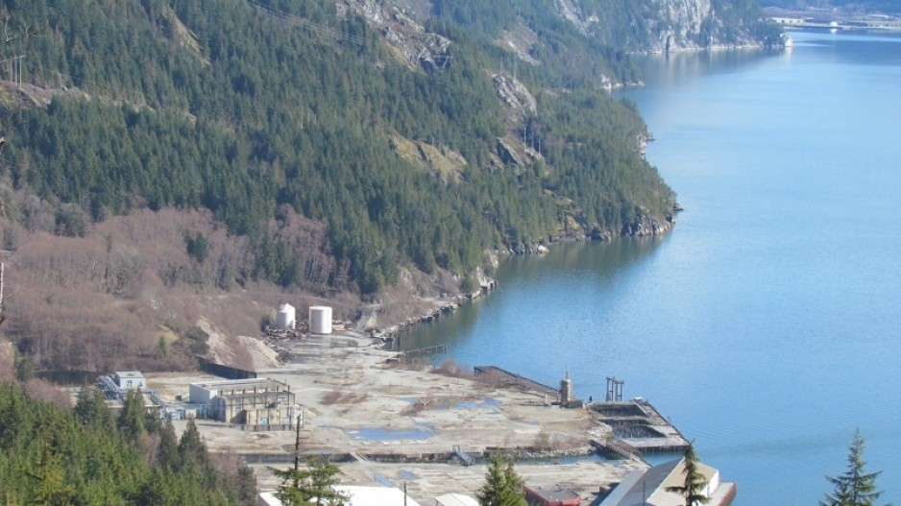
An old pulp mill site was chosen for the new $1.6 billion Woodfibre LNG plant in Squamish. | Squamish Chief
After years of delays, the $1.6 billion Woodfibre LNG project in Squamish is finally officially a go.
Woodfibre LNG announced today it has issued a notice to proceed to its main contractor McDermott, with major construction to begin in 2023.
Last month, Pacific Energy Corp. approved more than $600 million (US$500 million) in spending for the project in 2022 for pre-construction. Now, the main contractor has the green light to ready the project for full construction to start in 2023.
Woodfibre officially set up its office in Squamish in 2013. Several setbacks have pushed back a final investment decision and construction start date, requiring Woodfibre LNG to get extensions to its environmental certificate
Woodfibre LNG will be the second LNG plant built in B.C., after the much larger LNG Canada project in Kitimat.
Once construction work begins in earnest, the project is expected to employ a peak workforce of 650 people.
In addition to work on the actual LNG plant in Squamish, FortisBC, which will supply the plant with natural gas, needs to build a new connector pipeline. The 47-kilometre Eagle Mountain-Woodfibre Gas Pipeline will run from Coquitlam to Squamish. FortisBC expects construction to start on that project in 2023.
Compared to the $18 billion LNG Canada project in Kitimat, the Woodfibre LNG project is small, with an annual export capacity of 2.1 million metric tonnes, compared to LNG Canada's 13 million tonnes.
The plant will be among the first LNG plants to use electric drive, which lowers its carbon emissions intensity to an estimated 0.054 tonnes of CO2 equivalent per tonne of LNG (tCO2e/t). The global average emissions intensity of LNG plants, most of which use natural gas instead of electricity to drive the chilling process, is 0.26 to 0.35 tCO2e/t.
The project has the support of the Squamish First Nation, which has an impacts benefits agreement with Woodfibre LNG, the provincial government and FortisBC that includes $225.7 million in cash and nine parcels of land totaling 422 hectares.

